

HOTEL DATA ANALYSIS



Name: Vijay Kasotia

Email: vk73742@gmail.com

**Introduction**

The Best Southern Hotels and Spa operates three hotels (Bury Hill Golf, Willow Park Lakes, and Beavers lake and Golf Park) in Surrey. The hotels boast some of the best golf courses and fishing lakes. The clientele is aimed at middle-aged couples who enjoy fishing and playing golf. As I am regional manager (Kerry Spied) with the responsibility for marketing and the objective is to increase the customer base as well as customer satisfaction because it is the key to the success of their business.

Further, we have two Hotel Data sets which consist of complaint received and customers survey. Now, we are going to examine the given hotel data sets.

**Data Analysis**

Firstly, we are going to analyze and visualize the hotel data set of complaints received.

* Problem Generating Complaints

As shown above chart, there are seven types of complaints about three hotels. The highest number of complaints registered against the hotel Beavers Lake and Golf Park, while the lowest number of complaints registered against the hotel Willow Park Lakes.

The highest complaint registered for lack of maintenance of golf course at hotel Beavers Lake and Golf Park, whereas the lowest complaint (or no complaint) registered for the same type of issue at hotel Willow Park Lakes.

* Restaurant Complaints (01)

As shown above chart, poor quality food is the highest issue for the hotel Burry Hill Golf. Also, the maximum number of complaints or issues for all types is at Burry Hill Golf Hotel, whereas the minimum or lowest number of complaints against the hotel Willow Park Lakes.

* Restaurant Complaints (02)

As shown above chart, the maximum number of complaints (Spa room is cold) against the hotel Beavers Lake and Golf Park. However, the hotel Beavers Lake and Golf Park has experienced the minimum number of complaints about the type of issue is pool temperature cold and poor spa and pool sanitation. Further, the hotel Burry Hill Golf faces maximum number of complaints about all types of issues.

Let’s take another look through the pie chart (see below).

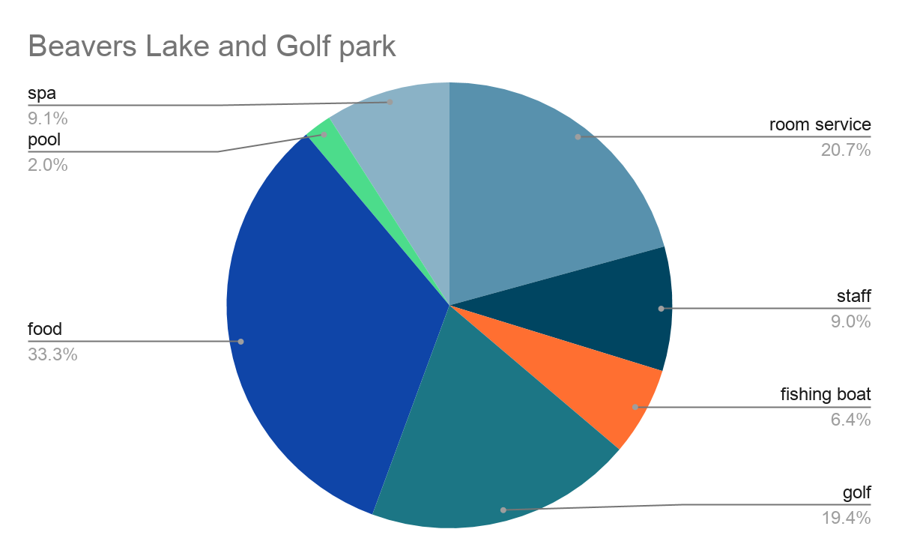

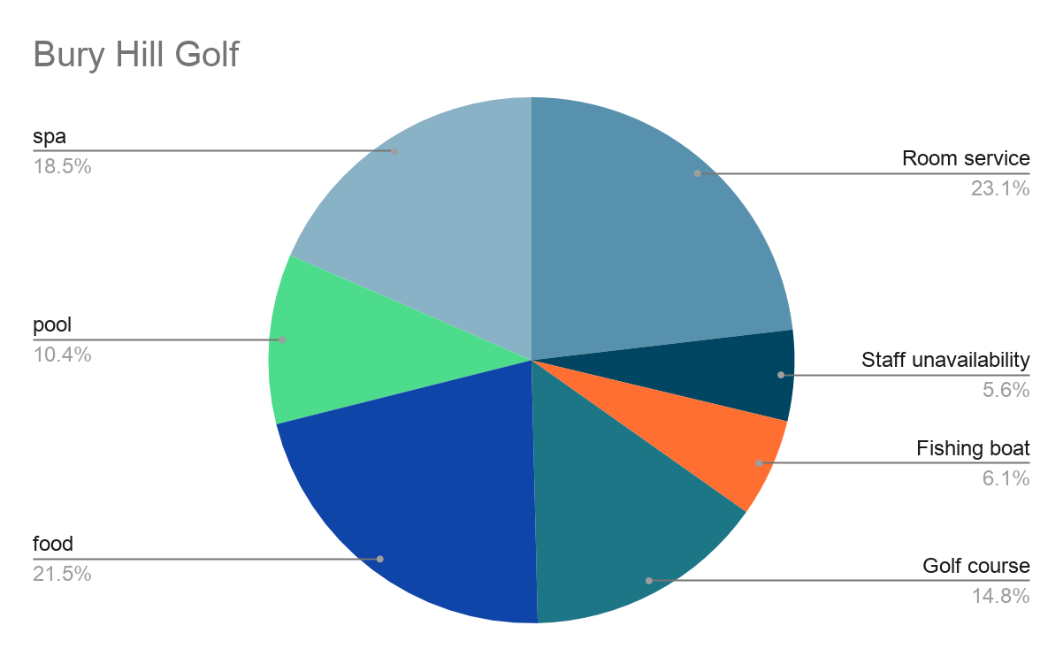

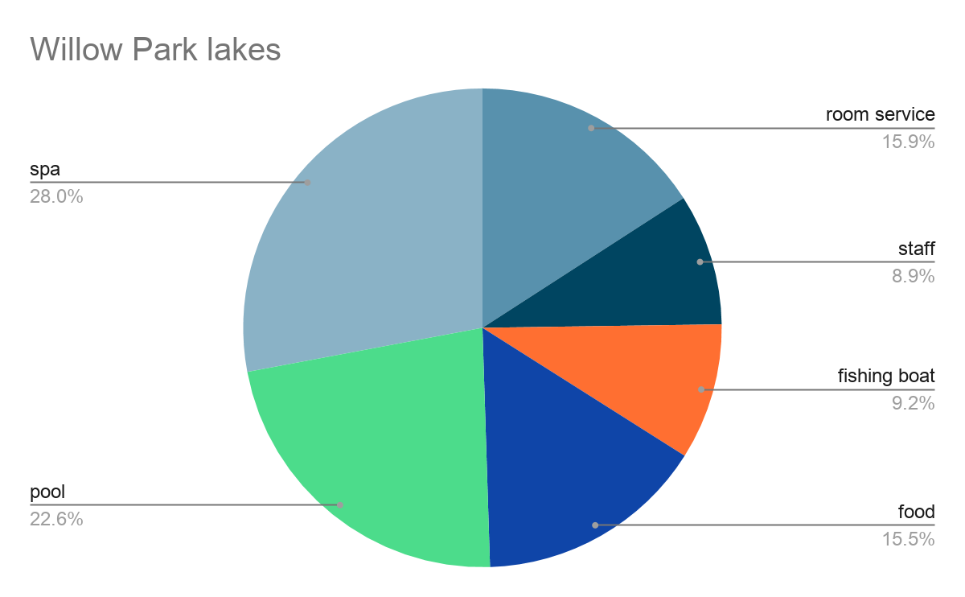

Hence, from the pie charts, we again get the same result as explained above.

Now, we going to analyze and visualize the hotel data set of customers survey.

* Bury Hill Golf

Customers are strongly agreed with the Bedrooms are always cleaned daily, Staff is available, helpful and provide good customer service, and Golf course always well-manicured which are the lowest number of complaints, whereas the customers agree with Fishing boat and staff is always available at the specified times for fishing trips which is the highest number of complaints and also customers strongly disagree with the same issue i.e., a second lowest complaint among all.

* Willow Park Lakes

The lowest (or zero) complaints for Golf course always well-manicured, Golf Caddy are always available at the specified times (for Strongly Disagree, Disagree, Agree, Strongly Agree). Customers are agreed with Bedrooms are always cleaned daily and Fishing boat and staff are always available at the specified times for fishing trips which are the highest number of complaints registered for this hotel.

* Beavers Lake and Golf Park

Customers are strongly agreed with Good value for money is the highest complaint among all, whereas customers disagree with the Fishing boat and staff is always available at the specified times for fishing trips are the lowest number of complaints.

Finally, after the survey, one can see key trends. One of the major trends that can be pointed out is the fact that Bury Hill Golf and Beaver Lake and Gold park hotels are the ones with the most complaints, whereas Willow park Lakes have very few complaints in comparison.

Moreover, most of the complaints received by both Burry Hill Golf and Beaver Lake and Gold park say that the overall performance of the hotel is dissatisfactory rather than just one department. There have been more complaints in all aspects of the management and not just one. This shows that there needs to be a huge change in the management as a whole in these two hotels. But Willow Park Lakes has had considerably fewer complaints, the hotel has received complaints mostly for food and for the pool conditions and not the entire management as a whole. On the other hand, more customers are agreed with Bedrooms are always cleaned daily, Staff are available, helpful and provide good customer service, and Fishing boat and staff are always available at the specified times for fishing trips.

In the given data it can be very well seen that pool maintenance, especially sanitation and food quality, and hygiene have had more complaints in all three hotels than the rest of the activities.

All these complaints from the customers can be changed into positive if there are changes in the management. In the data presented to us a lot of key areas in the management needs changing. From the data given it's very obvious that the management lacks man management and allocation of duty effectively. The hotel lacks in their basic functions such as room service, staff allocation, and serving the food not the right time, etc. The key attraction of the business such as golf and fishing are inefficient, if the main attraction is not efficient then it gets very difficult to attract customers. More effort should be put into the key areas and the main attraction so that the customers are satisfied.

Along with the data given, we need more data to find clearer decisions. We need to find whether the management is poor in managing or the staff is inefficient. This would help in knowing what's going wrong and can change accordingly. If the management is not managing the hotel, then the management needs to be changed but if the staff is being disobedient then the staff members can be changed. These will help to solve the problem.

From the above observation, it's safe to say that key changes need to be made and immediately in all three hotels to increase the hotel visitors count.

# Bibliography

Megan Wenzl. (2018, 12 20). *How to Improve Hotel Marketing to Create Customer Loyalty*. Retrieved from Hotel Speak: https://www.hotelspeak.com/2018/12/how-to-improve-hotel-marketing-to-create-customer-loyalty/

(2020, 06 01). Retrieved from CallMiner: https://callminer.com/blog/15-surefire-ways-to-improve-customer-satisfaction/

*IMPROVING CUSTOMER SATISFACTION*. (n.d.). Retrieved from Sales Force: https://www.salesforce.com/products/service-cloud/best-practices/how-to-improve-customer-satisfaction/

Kirill Tšernov. (n.d.). *Qminder*. Retrieved from Qminder: https://www.qminder.com/customer-satisfaction-strategies/